3. Host a multi-instance wordpress behind AWS ALB.

* Use the Autoscaling group once you are able to set up Wordpress without autoscaling.

**MyWork**:

* Create image of existing wordpress installed EC2 instance
* Launch an instance with the wordpress ami

**Wordpress instance behind ALB:**

* Create a target group with these two wordpress instances.
* Create an ALB with the created target group
* Modify the ALB security group to allow HTTP inbound rule
* Use the ALB’s DNS to route route between our two wordpress instances

**Output:**

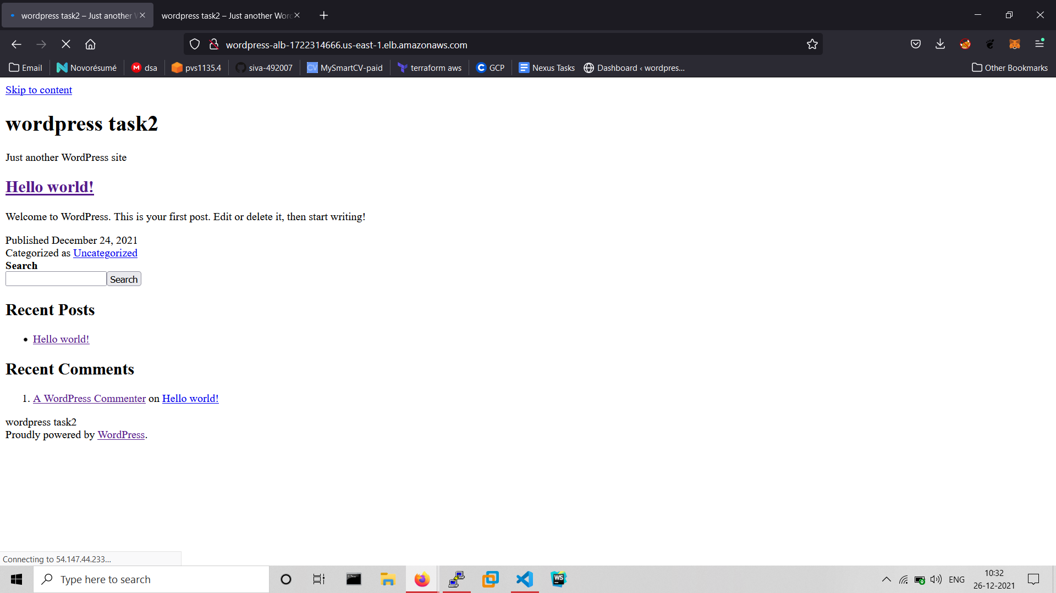

**Autoscaling:**

* Create a Launch Configuration with our wordpress ami
* Choose the instance type to t2.micro
* Modify security group to allow HTTP inbound rule.
* Choose an existing keypair.
* Create an Autoscaling Group with the created Launch Configuration.
* Choose default vpc and 3 availability zones.
* Choose an existing Load Balancer’s target group, which we created previously.
* Add desired capacity to 2
* Add minimum capacity to 1
* Add maximum capacity to 3
* In Target tracking scaling policy, choose CPU utilization value to 50%

**Output:**



